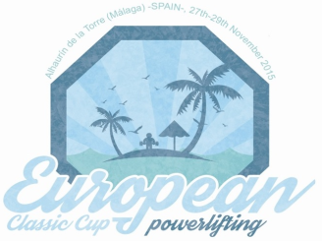
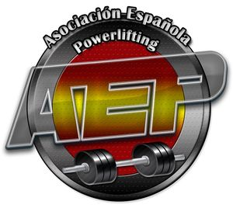
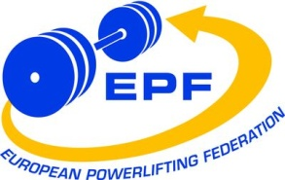
NOMINATION FORM
PRELIMINARY:  11th October 2015 | FINAL:  5th November 2015 | Last day to cancel the booked hotel rooms:  19th November 2015

The European Powerlifting Federation and the Spanish Powerlifting Association invite for the
1st European Open Classic Powerlifting Cup, men & women
1st European Open Classic Bench Press Cup, men & women
Alhaurín de la Torre (Málaga) -SPAIN-, 27th - 29th November 2015
THE NOMINATION FORM MUST BE SENT TO:
Original: Meet Director, Alejandro Rodríguez, Jarapalos 14 (gym) , 29130 Alhaurín de la Torre, Málaga, Spain
Mobile: +34 620 715 280, e-mail: MalagaPowerChamp@gmail.com
Copy: EPF Secretary G., Ralph Farquharson, Galena 5, Casa 44, Villapiedra, 03189 Orihuela Costa, Alicante, Spain
Phone: +34 966 733 367, Mobile: +34 650 041 559, e-mail: ralph@europowerlifting.org
Official website: www.europowerliftingmalaga.com
(Please, use for each person his surname and whole first name, not only first type of the name or nicknames!!!)
Submitted by |  | National Powerlifting Federation/Association

Submitting officer: |  | Title: |  | Date:

Teammanager : |  | Head Coach:
REFEREES NOMINATION:
Each referee must state which championship and group he/she will be free from other duties (coach, lifter, ...) in column “Available for categories”. If available categories are not stated, he/she may be nominated for both championships in all the categories.
It is an obligation of every Federation to confirm the participation of all their Referees nominated in the Final Nomination or cancel the Referees who will not participate in the Championships !!!
Latest date for changes of categories for which has been allocated must be made latest 7 days prior to the Technical Meeting of the competition. If referees do not indicate changes during that time, referees are obliged to be available for the original categories stated.
If a National Federation nominates more than one lifter, they must nominate at least one referee to their team available for refereeing or for Jury, who must develop his/her duties at least at one of the championships.
Referee 1 : |  | Cat : |  | Available for categories:

Referee 2: |  | Cat: |  | Available for categories:

Referee 3 : |  | Cat : |  | Available for categories:

Referee 4: |  | Cat: | 1 | Available for categories: | Only for Jury in case of insufficient # of Cat. 1
NOMINATIONS:
The number of lifters allowed in each day & in each body weigh category is limited. So, it's important to send your nominations as soon as possible in order to guaranty your participation in these championships

1st European Open Classic Bench Press Cup, men & women
M/W | FAMILY NAME | FIRST NAME | BIRTHDAY | BODY WEIGH | BP

1st European Open Classic Powerlifting Cup, men & women
M/W | FAMILY NAME | FIRST NAME | BIRTHDAY | BODY WEIGH | SQ | BP | DL | TOTAL

REGISTRATION OF OTHER TEAM MEMBERS:
(team leader, assistant coach, doctor, physiotherapist, assistant, delegate, etc.)
FAMILY NAME | FIRST NAME | DUTY
ACCOMMODATION:

SINGLE  Rooms | DOUBLE  Rooms | TRIPLE  Rooms | FROM  (date) | TO  (date) | Number of Nights
TRANSFERS FROM/TO AIRPORT or TRAIN STATION:
For 1 to 4 people: 35€ - For 5 to 7 people: 60€. Special prices when arriving 8 and more people.

Arrival DATE | Arrival TIME | By Flight/Train/Car | Airport or Train Station | Flight Number | Number of People

Departure DATE | Departure TIME | By Flight/Train/Car | Airport or Train Station | Flight Number | Number of People
CONTACT ADDRESS: obligatory to fill in
Name: |  | Street: |  |  | Zipcode:
City: |  | Country: |  | Phone:
Fax: |  | E-mail:

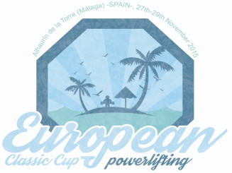
VISA SUPPORT FORM

Spanish Powerlifting Association
Name: Luis Tudela, Address: Antonio Machado 43 (2-2), 08788 Vilanova del Cami (Barcelona), SPAIN
tel.: +34 620 715 280, e-mail: PresidenteAEP@gmail.com

Family Name | First Name | Duty | Birth Day | Passport Number | Expiration Date

